

**Implantation IESN**

**Département technique**

**1 IG/TI/IR/RT/DA/INTAR**

**ANGLAIS GÉNÉRAL**

**SYLLABUS ANGLAIS TECHNIQUE**

**Justine DE WITTE**

**Stéphanie HAYEN**

**Ophélie KRUYTS**

**Thomas HENDRICKX**

**Année académique 2023 – 2024**

**CHAPTER 1: AN INTRODUCTION TO PROGRAMMING LANGUAGES**

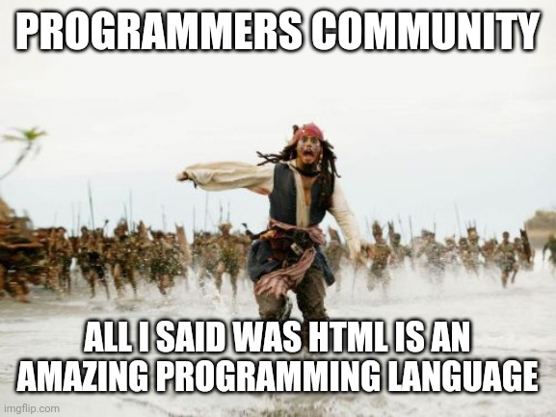

1. **Computer Science Basics : Programming Languages**
   1. **Introduction**

* How would you define “programming language” in English? How does it work (roughly)? Explain it step by step.
* They’re languages that computers can understand.
* Learn about them online (or follow specific courses).
* Give some examples of programming languages.
* Python, Java, Java Script, C, C++, Matlab, HTML, ect, …

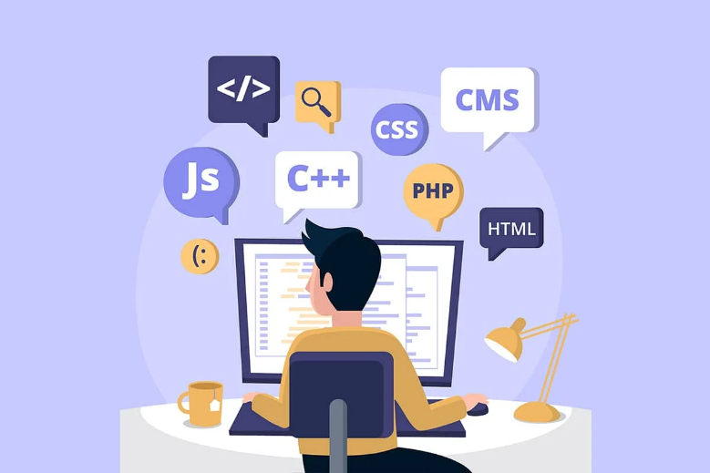

* 1. **Listening Comprehension**

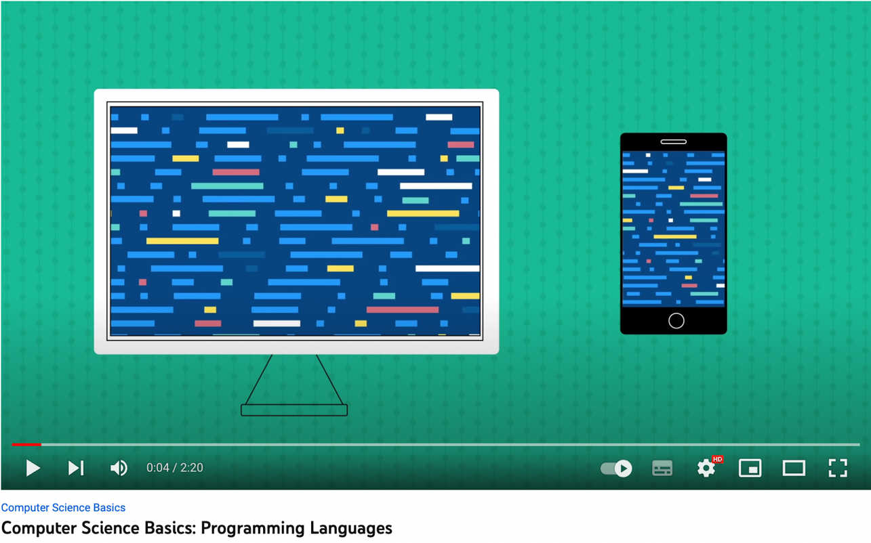Watch the video[1] about programming languages and answer the questions below in English.

1. **Fill in the gaps in the very first sentence in the video.**

“*Everything we do on* ***computers*** *and* ***smartphones*** *has some sort of ……………………………. behind it, telling it what to* ***do*** *But have you ever* ***thought*** *about how this code gets* ***written****?*”

1. **“*There are thousands of different languages in the world around us, but not so many in the digital world*”. True or false? Correct if the sentence is false and explain if it is true.**

False -> there are as many languages in the digital world as in the real world

1. **What does the video imply when talking about “output”? *(0:27)***

Output = sortie (du code) -> specific terms and direction used to create out put.

* Websites, apps and any kind of software.

⚠ 2 softwares it’s false (pas de S)

1. **“*Languages like JavaScript, Python and Java are used everywhere to make things like desktop apps and games, for example, and C++ is often used by websites for a variety of different purposes*”. True or false? Correct if the sentence is false and explain if it is true.**

False 🡪 it’s the other way around.

1. **“*HTML and CSS are not technically programming languages*”. True or false? Correct if the sentence is false and explain if it is true.**

True 🡪 Used to create the structure and appearance of almost every websites.

1. **Why are there a lot of existing programming languages?**

They’re all unique and operate differently from one other.

1. **Explain the “vehicles analogy” (1:11).**

It all comes down to your own and personal preferences (same as for cars).

1. **For instance (= for example), what language might a web developer and a video game designer use?**

A web developer may use JavaScript because it works well with HTML.

A video game designer may use C++ because it can handle (= supporter), more complex graphics.

1. **Fill in the gaps in the last two sentences in the video.**

“*Without programming languages, most of the* ***Technology*** *we use on a* ***Daily*** *basis (= de manière journalière) would be useless. When it comes down to it, they are simply the* ***Backbone*** *of all of our* ***Software***"

1. **Match these words from the video with their correct definitions, then translate them.**

|  |  |  |
| --- | --- | --- |
| a desktop | the main strength or support of something | La colone vertébrale, Le pilier |
| to power | small or compact enough to fit or be used on a table | Un PC/ Un Bureau |
| the backbone | to manage, deal with, or be responsible for | Supporter, Gérer |
| to handle | large or big | Encombrant, Volumineux |
| bulky | to supply force to operate | Alimenter, propulser, être en marche |

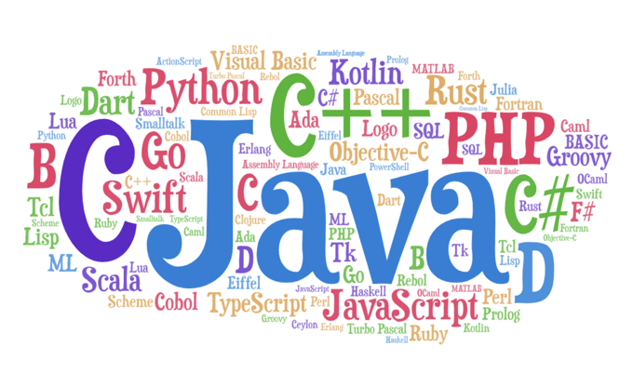

* 1. **Reading Comprehension**

Read the text[2] below and then have a look at the task related to the text on page 7.

**Why Are There So Many Programming Languages?**

There are so many programming languages out there, and more are developed every few years. We have Python, JavaScript, PHP, C++, Ruby, Java, C#, and way too many more to list here. So you might be wondering – why are there so many programming languages, and do we even need all of them?

## **The Evolution of Technology and Programming Languages**

The first and perhaps the biggest reason why we have so many programming languages is that technology is always evolving. As more technologies come into being and advance, we need more tools that can make software for these technologies.

The programming languages we currently have might not be able to deal with specific problems that arise because of the nature of the languages' capabilities. The issue might be so unique that there are no existing solutions that address their needs, so people or companies decide to create a new language themselves.

Here are some notable examples of programming languages that developed from specific needs:

1. *C* – Dennis Ritchie and Bell Labs created C in 1972 to overcome older languages' problems. They first used it to run the Unix operating system. Today, it can run on almost all kinds of software and hardware.
2. *C++* – Bjarne Stroustrup create C++ in 1985 for two main reasons. The first reason was to upgrade the features of the C programming language, and the second reason was to make it accessible for everyone to use in all fields.
3. *PHP* – PHP was created in 1994 by Rasmus Lerdorf, and he initially used it for a personal project. Later he improved the language and released it to the public, and developers started using it heavily for web development.
4. *Go* – Google created Go in 2009 because the languages they worked with at the time took were too slow and inconvenient for certain tasks. Also, Google wanted a programming language that was fast in performance but still relatively simple to read.
5. *JavaScript* – Netscape created JavaScript in 1995. They initially created it for front end development so both web developers and designers could learn and create website features in a short timeframe. Now we use it for back end, front end, and mobile development.

## **Different Kinds of Developer Jobs Require Different Languages**

Another reason we have so many programming languages is that there are different kinds of developer jobs out there that require different tools.

Think of it like a doctor and their patients. A doctor's job is to treat patients. There are different kinds of illness and injuries, and each one is complex enough to treat with different remedies. So doctors specialize in certain areas such as a cardiology, dentistry, surgery, and so on.

The same is true for programmers. As there are different kinds of software and platforms, each one requiring its own tools and features, programmers can specialize just like doctors.

Here are some developer jobs and the main programming languages they use:

* *Game developers* use C++ or C# to make video games for PCs and consoles.
* *Web developers* use HTML, CSS, JavaScript, and PHP to make websites and web applications.
* *Mobile app developers* use Java and Kotlin to make Android applications or use Swift to make iOS applications.
* *Software developers* use C++, C#, and Java to make desktop applications, business applications, and system software.
* *Data scientists* use Python, R, and MatLab to analyze data for scientific research and educational purposes.

These aren't the only languages you can use to perform these tasks. These are just examples of some of the most commonly used.

## **Developer Have Different Needs and Goals for their Projects**

The third reason there are so many programming languages is that not all of them will meet a developer or a company's goals. Different developers have their own goals and priorities, and some programming languages are better suited for certain types of tasks than others.

* Some developers want a programming language that's super fast and performant. Welcome Go or C++. These languages enable very granular control over system resources like memory and threads.
* Other developers want a programming language that can build the program in a few days and not weeks. Say hello to JavaScript! It's hard to find a more versatile language. You can use JS everywhere from the backend to web and mobile apps.
* Then some developers prefer a programming language for a specific task. In 2021 a ton of data science gets delivered in Python.
* And finally, some developers want a programming language that is fun to work with. Try Haskell or Lisp, for instance, and see how it goes.

To sum it up, the main reason why there are many programming languages out there is that different problems require different tools to solve them. Each programming language has certain features and characteristics that make it suitable for specific tasks. Just like how doctor's jobs are divided into various specialties, and each solves complex problems and uses the right tools for their job, the same is true for programming.

**QUESTIONS (answer in English):**

* 1. What is the first and biggest reason why we have so many programming languages?

The first and biggest reason of why we have so many programming languages is because a different kind of developer jobs have a different needs.

Because technology is always boiling: because there are more tools, we need more programming languages.

* 1. “*There are enough programming languages nowadays, we do not need more*”. Is this sentence true or false? If it is false, correct it. If it is true, give more details.

False -> programming languages all have a specific purpose + you need to deal with very specific problems (new programming languages may arise because you need them to solve these issues).

* 1. Fill in the table below.

|  |  |  |  |  |
| --- | --- | --- | --- | --- |
| **Programming language** | **Launch year** | **Created by…** | **Reason(s) for its creation** | **Extra information** |
| C | 1972  (1) | Dennis Ritchie and Bell Labs  (1) | To overcome/solve (=surpasser, résoudre) older languages problems (1) | * It was first used to run the Unix OS (0.5) * Today, it can run on almost all kinds of software/hardware. (0.5) |
| C++ | 1985  (1) | Bjarne Stroustrup (1) | * To upgrade features of C/C’s features. (1) * To make it accessible for everyone. (1) | / |
| PHP | 1994  (1) | Rasmus Lerdorf  (1) | * He initially used it for personnel project. (0.5) * Later he improved the language and released it to the public (0.5). | Developers started using it for web dev. (1) |
| Go | 2009  (1) | Google  (1) | * Created because the languages they worked with were too slow and inconvenient (= inadéquat). (1) * Google wanted something fast and simple to read. (1) | / |
| JavaScript | 1995  (1) | Netscape  (1) | For front end dev so designers could learn and create websites in a short timeframe. (1) | For front and back end dev + mobile dev. (1) |

1. In your own words, explain the “doctor-patients” analogy.

We compare computers to body parts that need attendance (we need to care for them and heal them), just as doctor would do with patients.

1. Match these developer jobs with their main programming languages used and their purpose.

|  |  |  |
| --- | --- | --- |
| **Developer jobs** | **Purpose** | **Main programming languages used** |
| Mobile app developers | To make websites and web applications | Python, R, and MatLab |
| Game developers | To make Android or iOS applications | Java and Kotlin or Swift |
| Data scientists | To make desktop applications, business applications, and system software. | C++ or C# |
| Web developers | To make video games for PCs and consoles | C++, C#, and Java |
| Software developers | To analyze data for scientific research and educational purposes. | HTML, CSS, JavaScript, and PHP |

1. “*Developers all have a common goal and priority*”. Is this sentence true or false? If it is false, correct it. If it is true, give more details.

False -> because different developers have their own goals and some programming languages are better suited for certain types of tasks.

1. **Grammar : theory & exercises (*ALTISSIA*)**
   1. **LES DEMONSTRATIFS: THIS, THAT, THESE, THOSE**

<https://learn.altissia.org/platform/#/discover/GRAMMAR/ARTICLES/lesson/EN_GB_A1_GRAMMAR_ARTICLES_THIS_THAT>

* 1. **PRONOMS PERSONNELS SUJETS ET COMPLEMENTS**

<https://learn.altissia.org/platform/#/discover/GRAMMAR/PRONOUNS/lesson/EN_GB_A1_GRAMMAR_PRONOUNS_I_ME_ETC>

* 1. **LES POSSESSIFS**

<https://learn.altissia.org/platform/#/discover/GRAMMAR/POSSESSIVES>

* 1. **TIME & PLACE PREPOSITIONS + DEPENDENT PREPOSITIONS**

<https://learn.altissia.org/platform/#/discover/GRAMMAR/PREPOSITIONS>

* 1. **ARTICLES**

<https://learn.altissia.org/platform/#/discover/GRAMMAR/ARTICLES>

* 1. **COUNTABLES AND UNCOUNTABLES**

<https://learn.altissia.org/platform/#/discover/GRAMMAR/NOUNS>

**Chapter 4: choice & use of operating systems**

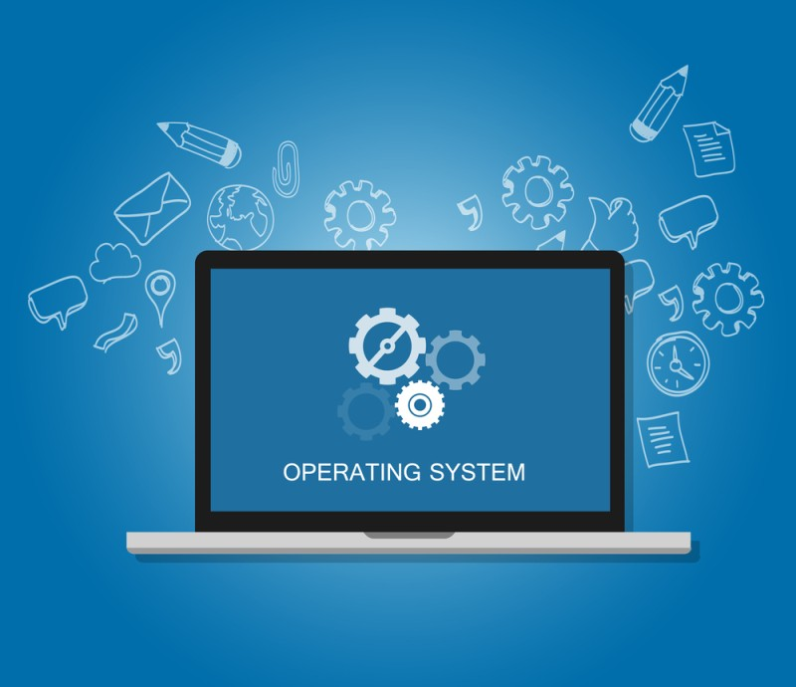

**Learning material mainly inspired by and taken from**

***“Information Technology: Unit 1” (Pearson BTEC, National Level 3)***

**as well as other sources provided and created by the language teachers**

1. **USER INTERFACE**
2. **INTRODUCTION (Examen)**

Write down English definitions for each term in this table. What do you know about them?

|  |  |
| --- | --- |
| **The user interface** | The way in wich the users communicate/intercat with the computer   * The OS provides the features |
| **GUI** = Graphical User Interface  (pronounced “goui”) | * It displays objects that convey info and represent actions that can be taken by the user. * The into on the screen can be colors, fonts(=police), size and visibility. |
| **WIMP** = Windows, Icons, Menu and Pointers | The style of GUI that uses the common Windows widgets |

1. **DEFINING USER INTERFACE (LISTENING EXERCISE)**

Watch the video[3] and check if the definition you wrote down for the term “*user interface*” is correct. Then fill in the table below: for each chapter from the video, write down all the pieces of information that you hear in English.

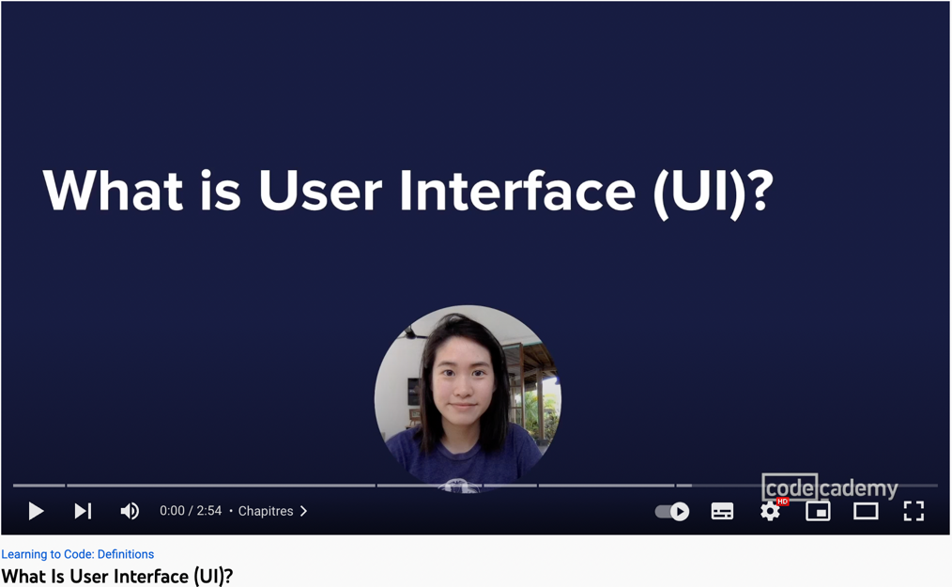

|  |  |
| --- | --- |
| UI 🡪 encompasses (= englobe) GESTURES (=movement) and VOICE, etc. | * It can be a click or a swipe. * UI is what the users will make these interactions on. * E.g ( for example). : a button on a website or a drop-down menu (= un menu déroulant) on a mobile app. * Link with switching/changing gears (=changer les vitesses):same with you interacting with the computer’s “engine”. * Now beyond a click/swipe 🡪 EVERYTHING. * E.g.: activate your smartwatch using hand gestures/orientation |
| Bad UI 🡪 decreases USER ENGAGEMENT (sur le long terme). | If not used correctly, it can result in some frustrating situations.   * Sometimes things may not be optimized for apps (small text/pictures). If users see this, they will leave the app. |
| Responsive designs 🡪 keep USERS HAPPY (=coherence / adaptabilité).  Consistency (=constance/coherence) 🡪 keeps USERS HAPPY | * It has to be visually-appealing (= qui attire le regard) experience. * There’s a consistent theme that persists. * Users have a seamless (= smooth 🡪 fluide/doux) experience while navigating though the apps. |
| UI and UX = User Experience | UX provides the users with VALUE.  It optimizes what UI does.   * UI always works closely with UX (hand in hand). * One does not go without the other. |

1. **THE DIFFERENT TYPES OF USER INTERFACE**

* COMMAND LINE INTERFACE

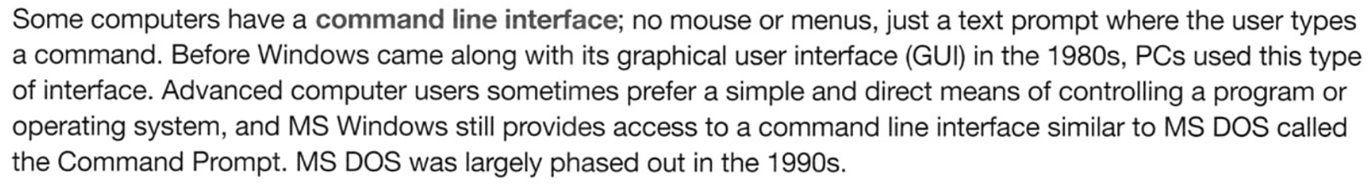Read what a “*command line interface*” is and answer the question below in English.

**QUESTION: according to this definition, what do these time spans correspond to?**

* In the 1980s 🡪 Windows came along with GUI.
* Before the 1980s 🡪 all PCs used the command line interface only (🡪CLI).
* In the 1990s 🡪 MS DOS was largely phased out (=disappeared).

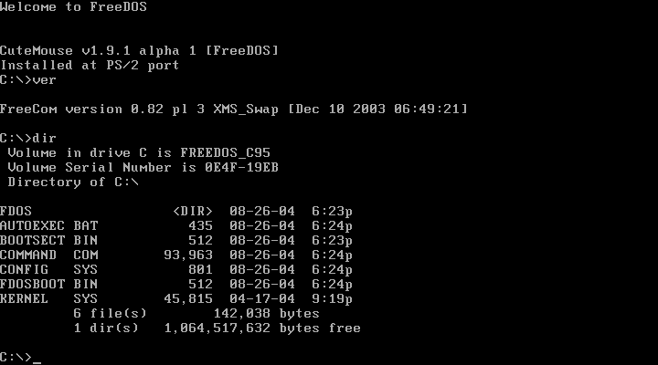

* MENU-BASED (or menu-driven) INTERFACE

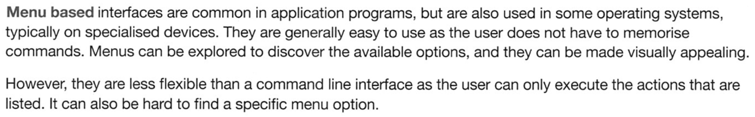Read the definition below, then answer the question below in English.

**QUESTION: list the pros and cons of a menu-driven interface.**

|  |  |
| --- | --- |
| **Pros** | **Cons** |
| * Easy to use. * The user does not have to memorize commands. * Visually-appealing. * Menus can be explored. | * Less flexible * The user can only execute the listed actions. * Difficult to browse throught BUT there’s a searchbar. |

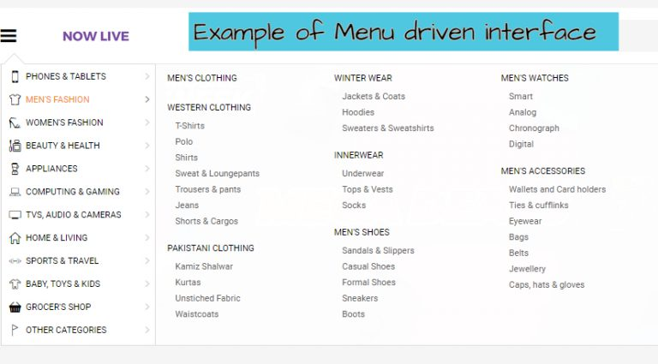

* ADAPTIVE INTERFACE

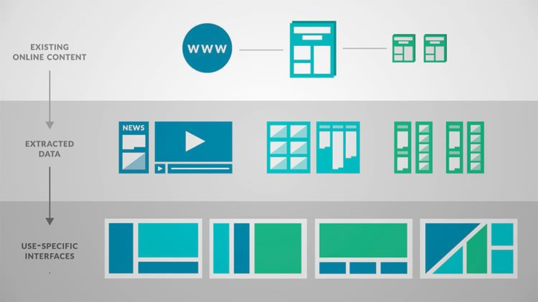Look closely at the picture below and try to describe in English how this type of interface works, then read the definition further below to check your answer.

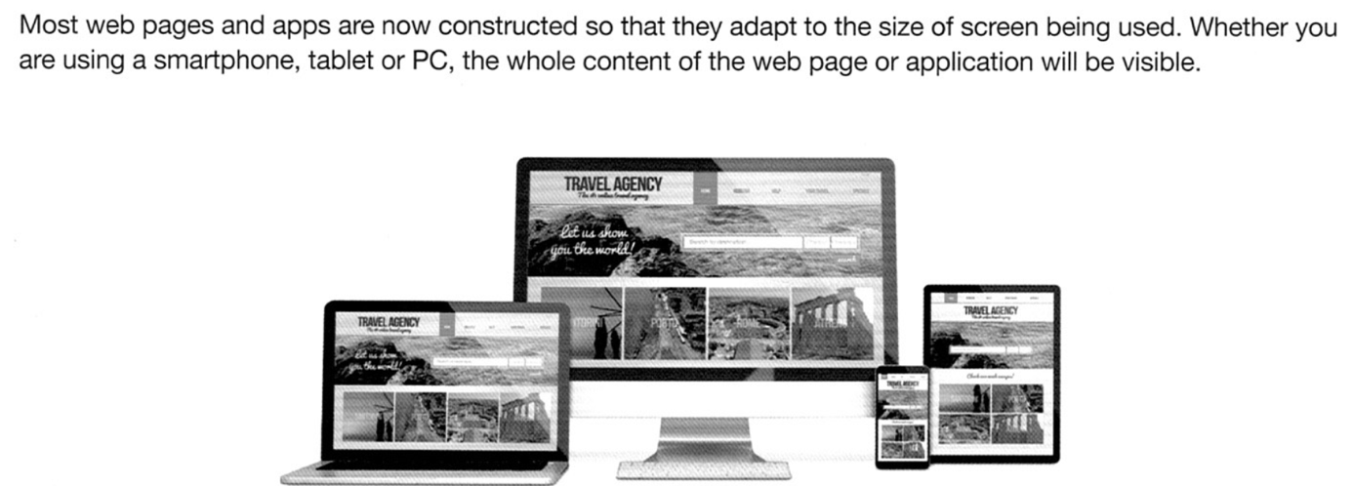DEFINITION:

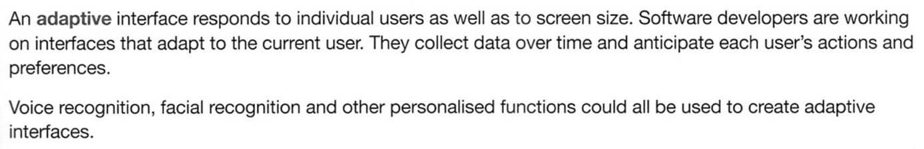

* EXAMPLES OF USER INTERFACE & CONCLUSION

Try to find relevant examples to illustrate the three types of interfaces we have seen and explain your choices to the rest of the group. To conclude, analyze the summary below.

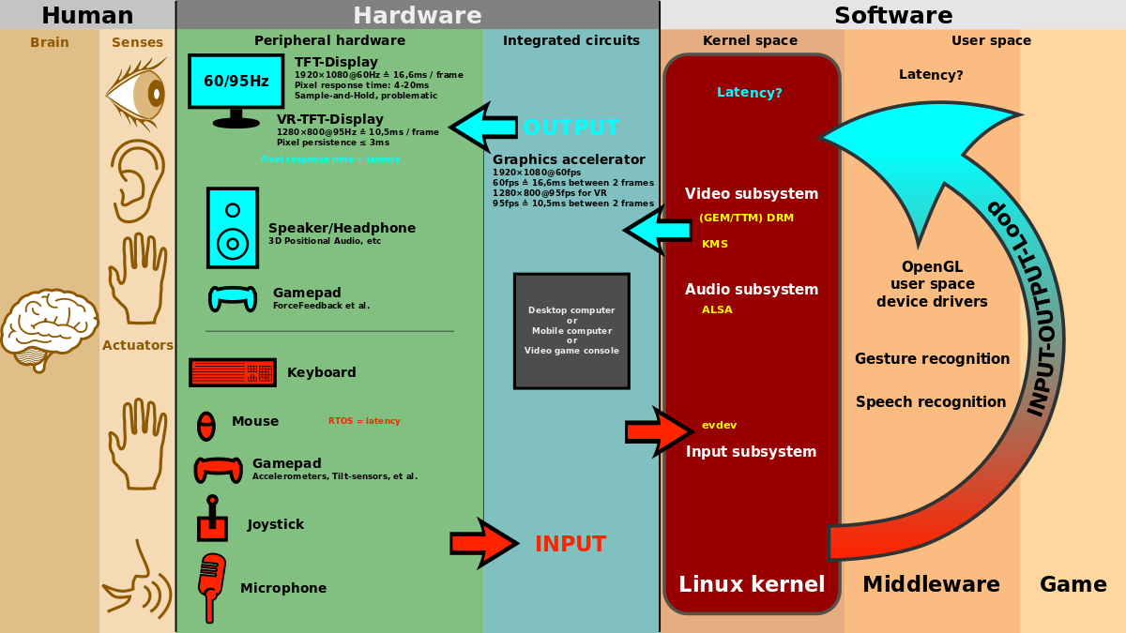

1. **FACTORS AFFECTING THE CHOICE OF USER INTERFACE**

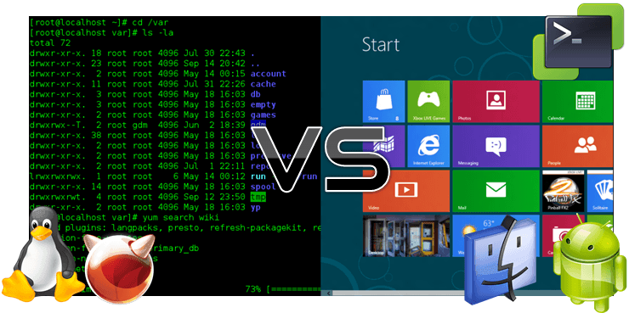Think about reasons why people would opt for a command line interface (CLI) instead of a GUI. Then compare your answers with what’s explained in the table on the next page.

|  |  |
| --- | --- |
| GUI | CLI |
|  |  |

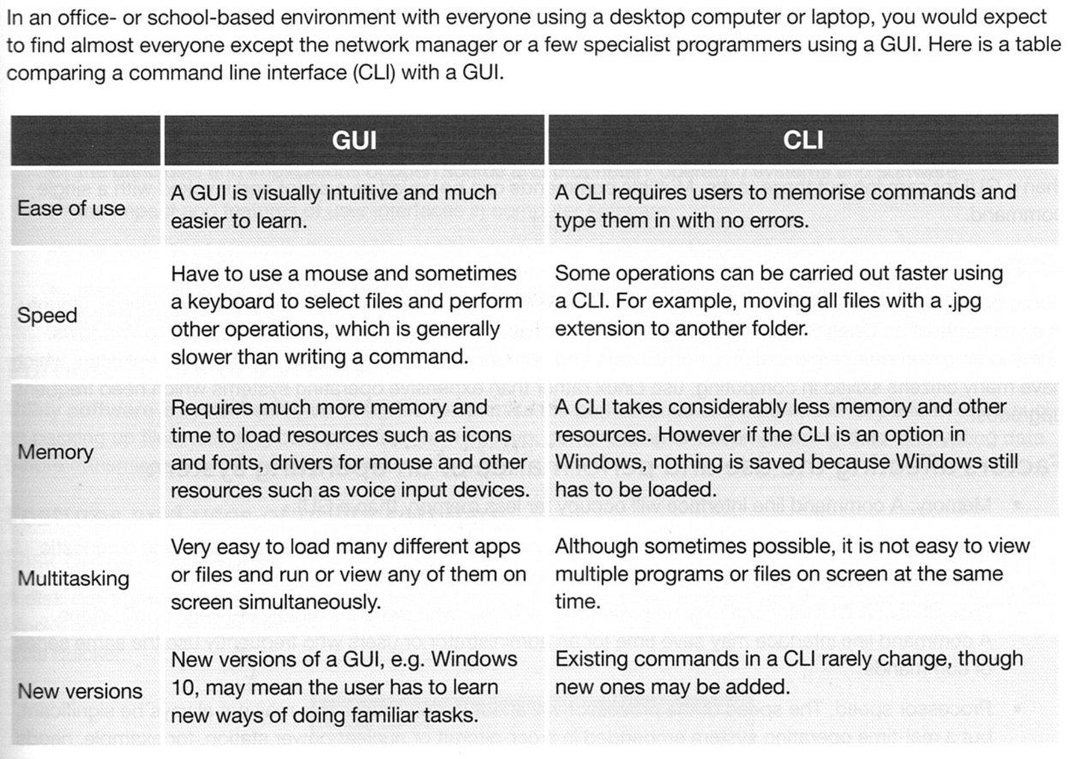

1. **FACTORS AFFECTING THE CHOICE OF OPERATING SYSTEM**

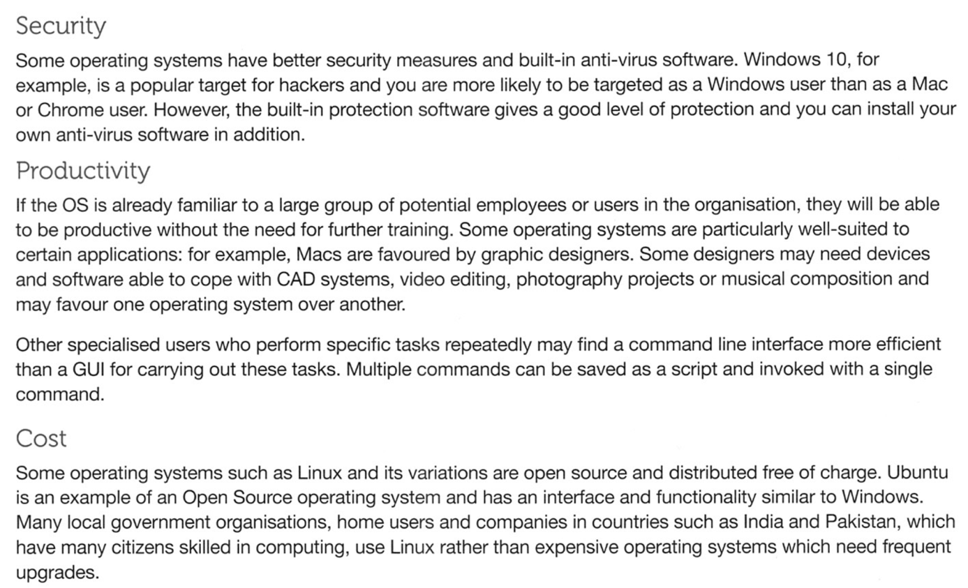Read the text below about factors that could affect the choice of operating system and fill in the table on the next page in which you sum up what may influence the choice of a specific OS.

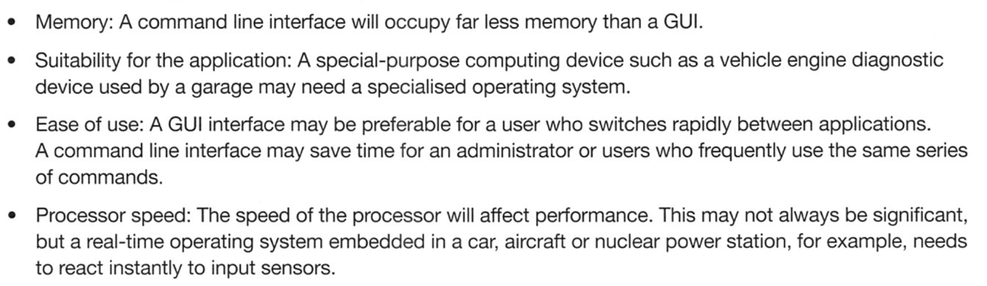

|  |  |  |
| --- | --- | --- |
| **SUMMARY – FACTORS AFFECTING THE CHOICE OF OS** | | |
| **1** |  |  |
| **2** |  |  |
| **3** |  |  |

🡪 browse through [this website](https://www.softwaretestinghelp.com/best-operating-systems/) to find out what **the 10 best OS for laptops and computers** are (spoiler alert: you will probably disagree with this ranking – but let the group know why so we can all debate on the matter 😉).



1. **GRAMMAR (*ALTISSIA*)**

* **Future tenses** (de A2 à B1)

<https://learn.altissia.org/platform/#/discover/GRAMMAR/FUTURE>

**CHAPTER 2: HISTORY & EVOLUTION OF PROGRAMMING LANGUAGES**

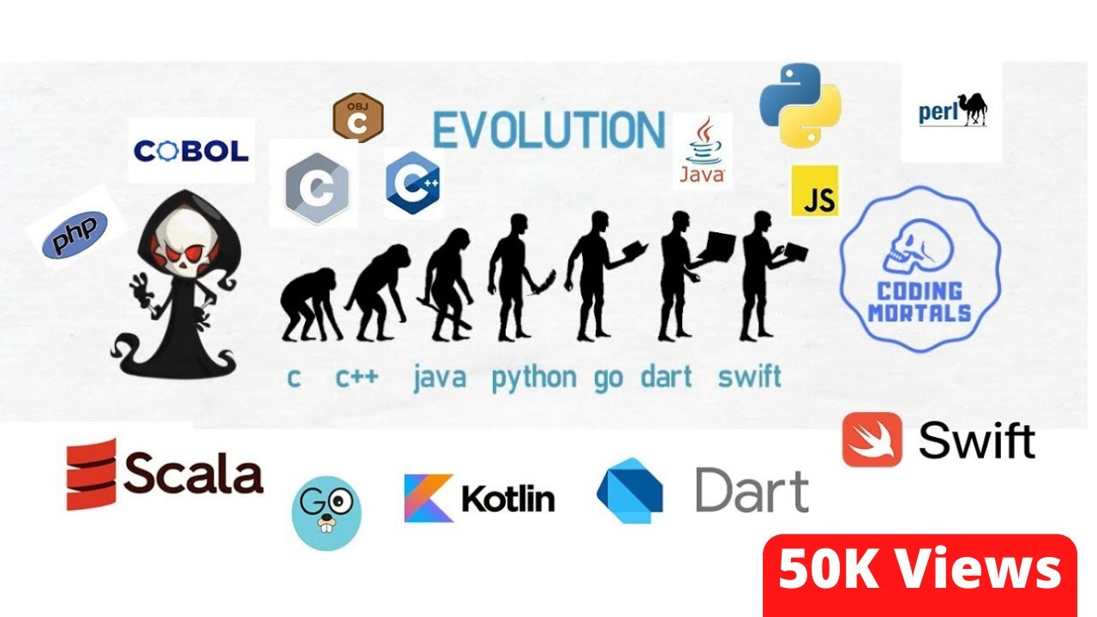

1. **Introduction: “A Brief History of Coding & Programming Languages” (reading comprehension)** *(from 0:00 to 1:26)*
2. **Match the pictures below with the events on the timeline.**

|  |  |  |  |
| --- | --- | --- | --- |
| Une image contenant texte, intérieur, plafond, rayon  Description générée automatiquementIn 1948, electricity was used to store memory (Manchester University).   * Via binary code * It took the size of an entire room. | Une image contenant personne, complet, homme, mur  Description générée automatiquementAlan Turing   * 1943 * During WWII, he cracked secret coded messages sent by the Germans. * Enigma machine (it helped end the war 2 years earlier) | **Une image contenant habits, personne, intérieur, noir et blanc  Description générée automatiquement1936: upgraded version of the Enigma machine (by Alan Turing -> MORE FLEXIBLE).**   * **Multiple instructions in binary code.** * **Main drawback (= inconvenient): read instructions on long tapes of paper …** | **Ada Lovelace (1843)**   * **Considered as the 1 st computer programmer + designed the 1 st algorithm.** |
| **Une image contenant logo, symbole, Graphique, Police  Description générée automatiquementUne image contenant logo, symbole, Graphique, Police  Description générée automatiquementUne image contenant texte  Description générée automatiquement**  **FORTRAN? LISP & COBOL (late 1950s -> 2nd half)** | **PERL (1987) -> IMDB, Amazon & Ticketmaster.** |   **1983 : birthyear of**  **C++ (still used today by Adobe + Google Chrome)** | **Une image contenant personne, intérieur, ordinateur, Périphérique de sortie  Description générée automatiquementTim Berners-Lee (1998): he invented the internet (HTML, URL + HTTPS)** |
|   **The 1990s : birth of Python, JAVA, JavaScript & PHP.**  Source: <https://www.youtube.com/watch?v=yhE9B7ya2xM&ab_channel=AlgoworksSolutionsInc> |

1. **Vocabulary exercise: match these words from the introduction with their correct definitions.**

|  |  |  |
| --- | --- | --- |
| **WORDS** | **DEFINITIONS** | **FRENCH TRANSLATIONS** |
| to be processed by (a machine, etc.) | invent, or create from existing principles or ideas | Inventer, concevoir |
| to crack | to accept, handle, and organize (data), esp. electronically | Traîter |
| a drawback | at the present time; now | Maintenant, Actuellement |
| to compel (someone) | a hindrance or disadvantage | Inconvénient, désavantage |
| currently | to solve or reveal, esp. after much effort | Cracker, résoudre |
| to devise | to force or drive (someone) to do something; require | Forcer, contraindre |

1. 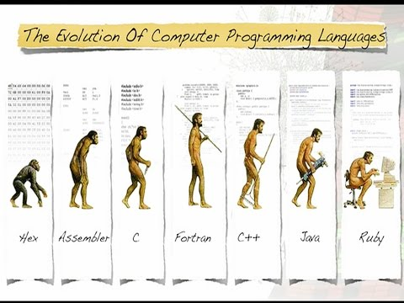**Before moving on to the next activity, what do you understand from this picture? What is it trying to illustrate? Explain.**

  
Click on this link to check your answers 🡪 <https://medium.com/@mahmutatas/history-of-programming-144fd91ee386>

1. **A Focus on Early Programming Languages** *(from 0:00 to 4:00)*
2. **Watch the video[4] and fill in the following true-or-false table in English.**

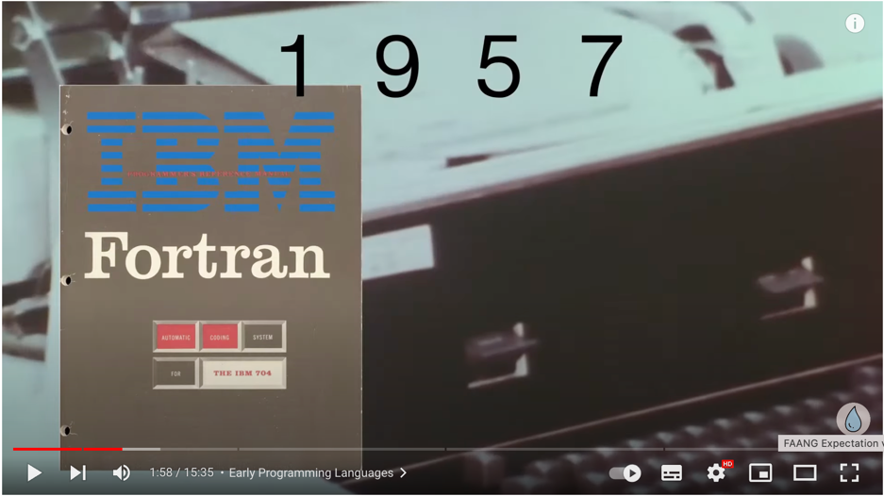

|  |  |  |  |
| --- | --- | --- | --- |
|  | **STATEMENTS** | **TRUE OR FALSE? (/1)** | **JUSTIFICATION/DETAILS**  **(/1)** |
| **1** | It wasn’t shocking for Ada Lovelace to study mathematics in 1883. | TRUE – FALSE | It was atypical at that time to study maths for a woman. |
| **2** | Charles Babbage is considered to have developed the first computer programming language. | TRUE – FALSE | He’s an English mathematician. |
| **3** | In 1949, “Assembly” was created and with its creation came a breakthrough discovery (=une découverte révolutionnaire). | TRUE – FALSE | He discovered the 79 digit prime number (the largest). |
| **4** | “Auto Code”, developed in 1952, can be considered as a singular programming language. | TRUE – FALSE | It was a term used to describe the family of early programming languages. |
| **5** | The 1957 programming language “Fortran” completely disappeared and isn’t used anymore. | TRUE – FALSE | It’s still used widely today (developed by IBM) + powered supercomputers. |
| **6** | “Algol” can be considered as a pioneer in terms of programming languages. | TRUE – FALSE | It’s the basis for a lot of programming languages such as Pascal, C, C++, Java. |
| **7** | “COBOL” is not meant to be run on all brands of computers. | TRUE – FALSE | It’s meant to be run on all kinds of computers (used in ATMs = distributeur billets), finance, telephone, business, administration. |
| **8** | LISP is the oldest high-level programming language. | TRUE – FALSE | It’s the second oldest after Fortran. |
| **9** | 1964 saw the birth of “Basic”, which was meant for all students who wanted to know how to use computers. | TRUE – FALSE | It was meant for students who didn’t have a strong mathematical background. |
| **10** | The 1964 “Basic” version doesn’t exist nowadays anymore. | TRUE (– FALSE) | Bill Gates + Paul Allen altered Basic and became the first Microsoft product. |

1. **Vocabulary exercise: do you know how these French words were translated in English in the video?**
2. Un moteur, réacteur = an engine
3. Une jeune fille = a girl (Scottish word for « a girl » = a lassie / a lad = un jeune homme)
4. Anormal = atypical /abnormal (terme médical)
5. Être issu (de), tirer son origine (de) = to originate / to be originated from
6. Passer directement, “sauter” vers = to fast forward
7. Un chiffre = a number / a digit (a 4-digit PIN code)
8. Fonctionner à travers, via = to run throught
9. Vouloir dire, signifier = to mean / abbreviation = aka / to stand for
10. Être la référence = to benchmark
11. Un distributeur/guichet automatique (de billets) = ATM (Automatic Teller Machine)
12. Insinuer = to imply
13. Être composé de = to be make (up) of
14. Une éducation, un milieu = the background
15. Changer, modifier = to alter



Check out this link for a visually appealing overview of the history of programming language.

🡪 <https://venngage.com/gallery/post/the-history-of-programming-languages/>

1. **Grammar Altissia**

* **PRESENT PERFECT**

<https://learn.altissia.org/platform/#/discover/GRAMMAR/PRESENT/lesson/EN_GB_A2_GRAMMAR_PRESENT_PERFECT>

**CHAPTER 3: OPERATING SYSTEMS**

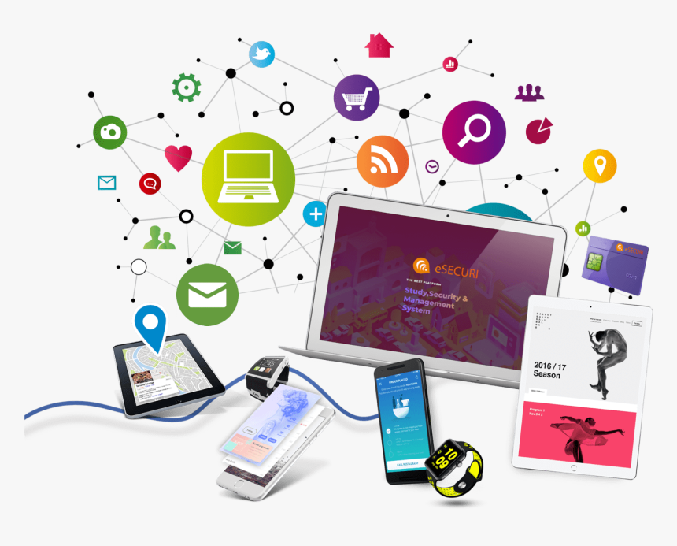

1. **INTRODUCTION**

**Discuss the following questions.**

1. What is an operating system? (examen)

Official déf : The law – level software that supports a computer’s basic functions 🡪 scheduling taxes (=planifier) + controlling peripherals.

1. What are its goals and functions?

A program allowing you to communicate and interact with your computer.

1. What operating systems do you know? Use the logos below to help you.

Windows, mac os, android, ios, linux, unbuntu, blackberry, FreeBSD, debian, linux mint, gnome, fedora

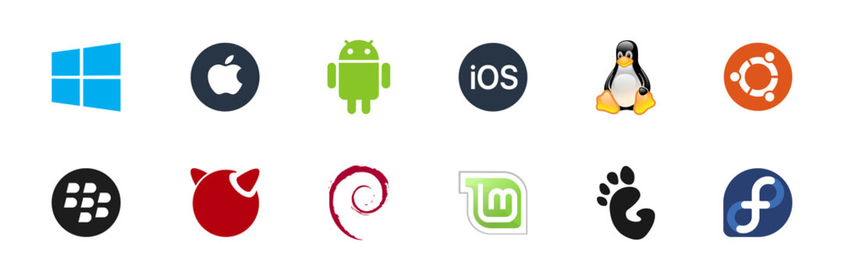

1. **Listening activity**

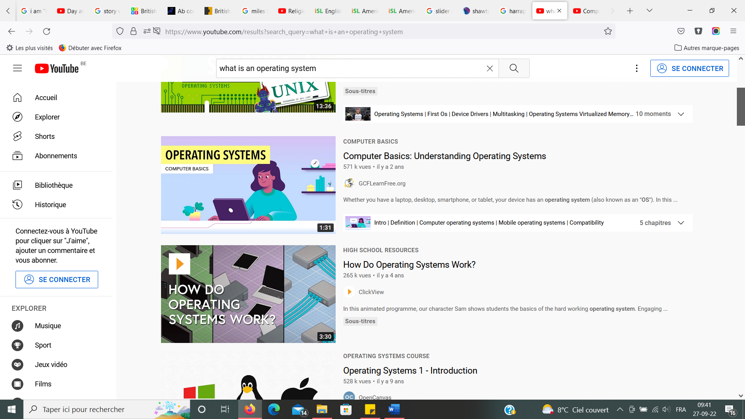

<https://www.youtube.com/watch?v=fkGCLIQx1MI>

**Watch the video and answer the questions in English.**

1. What language does the computer use?

It speaks in ones and zeros 🡪 binary.

1. What is the purpose (=goal -> but) of the operating system?

You can directly communicate with your computer thanks to the OS

1. What is an operating system?

It lets you interact with your computer

1. Fill in:

Together, the operating system and computer hardware form a complete (=whole) system that determines what your computer can do.

1. What are the most common operating systems?

Microsoft’s Windows and macOS

1. Fill in:

Windows comes preloaded/ pre-loaded (with a hyphen) on most peronal computers, while MacOS runs (=fonctionner) on all new Macs.

1. True or false? Justify.

“*Operating systems are only for desktop and laptop computers.*”

False 🡪 every device needs an OS (mobile)

1. What do you have to do before downloading a new program or application? Explain.

It may not be available for your OS 🡪 learn how your OS works.

1. **READING ACTIVITY**

**Read the text and answer the questions in English.**

**PART 1 :**

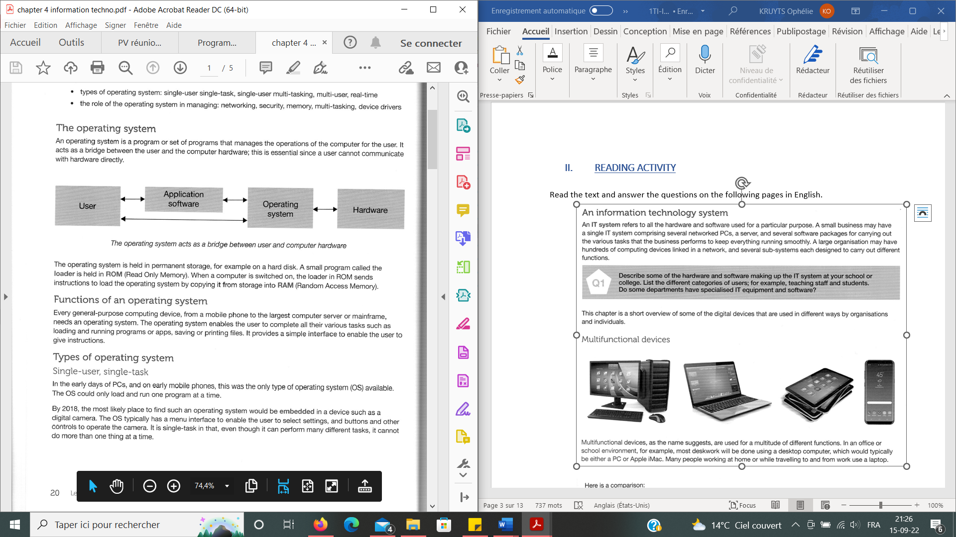

**1. True or false? Correct if the sentences are false or give details if they are true.**

1. The operating system is a bridge between the user and a software.

False computer hardware

1. Only small computing devices need an OS.

False 🡪 All devices need an OS

**2. Answer these questions in English.**

1. What could the first operating systems do?

Only load and run 1 program at a time (single-tasking)

1. Where can we still find that type of OS?

**In figital cameras**

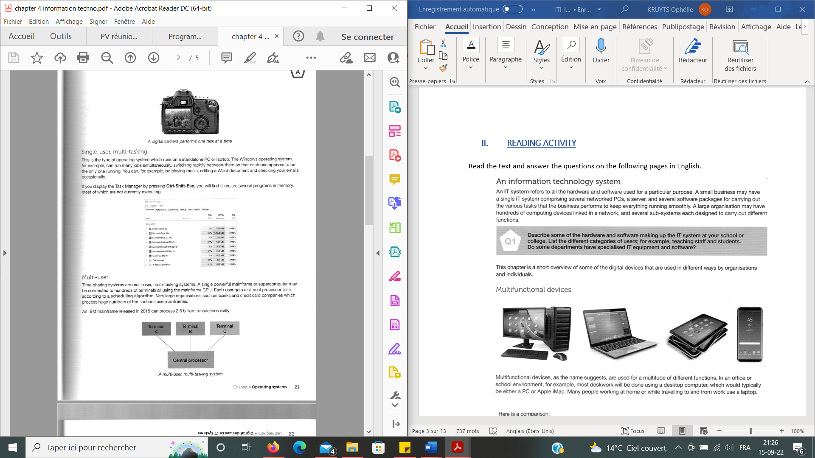



1. **Answer in English:** give two examples of organisations that use mainframes. Explain why they need them.

* **Banks**
* **Credit card companies Because of the many transactions they make everyday**

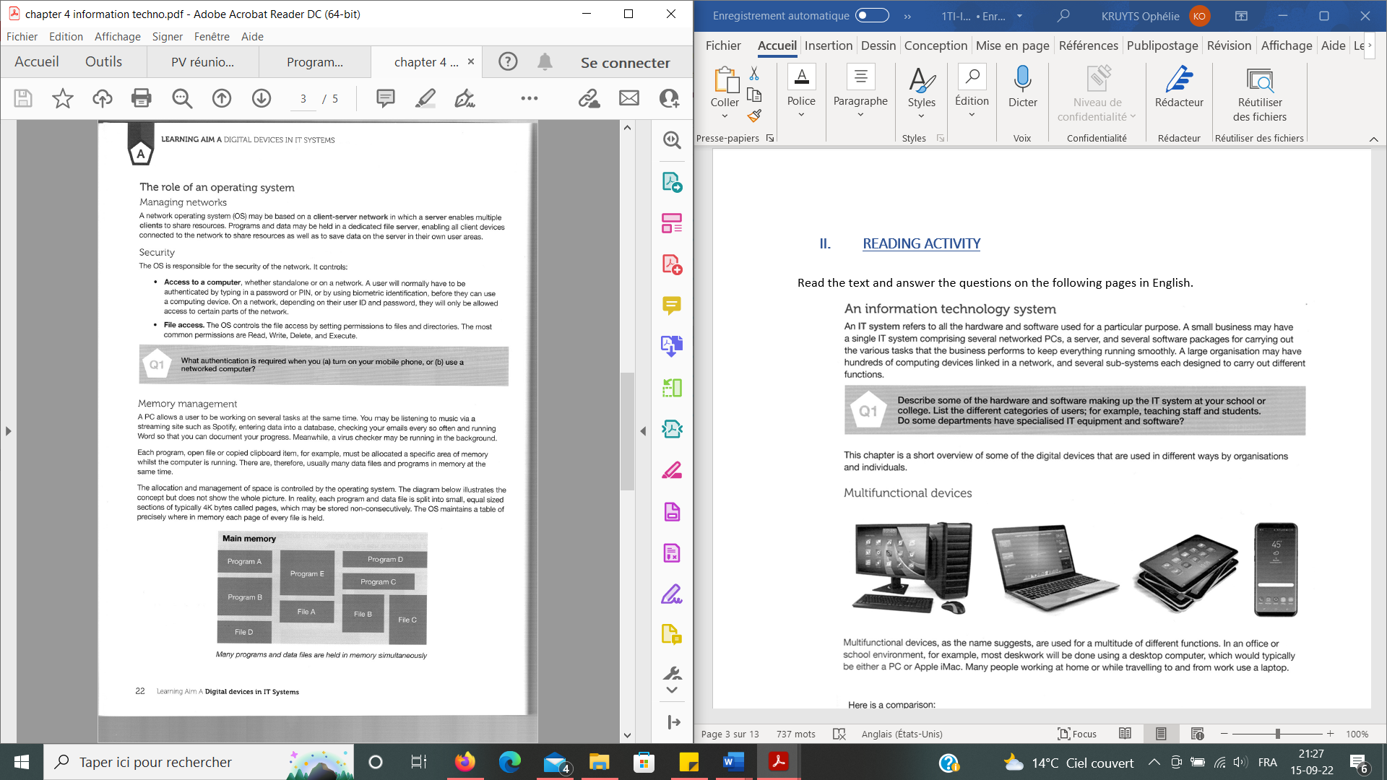

1. **True or false? Correct the sentence if it is false and give details if it is true.**

**“***A user does not have access to all parts of a network.*”

**True 🡪 acces Certain parts of a network**

**2. Answer the question:** What authentication is required when you (a) turn on your mobile phone or (b) use a network computer?

(a) PIN code + biometric identification (facial recognition + digital fingerprints)

(b)Password + user ID

**PART 2 :**





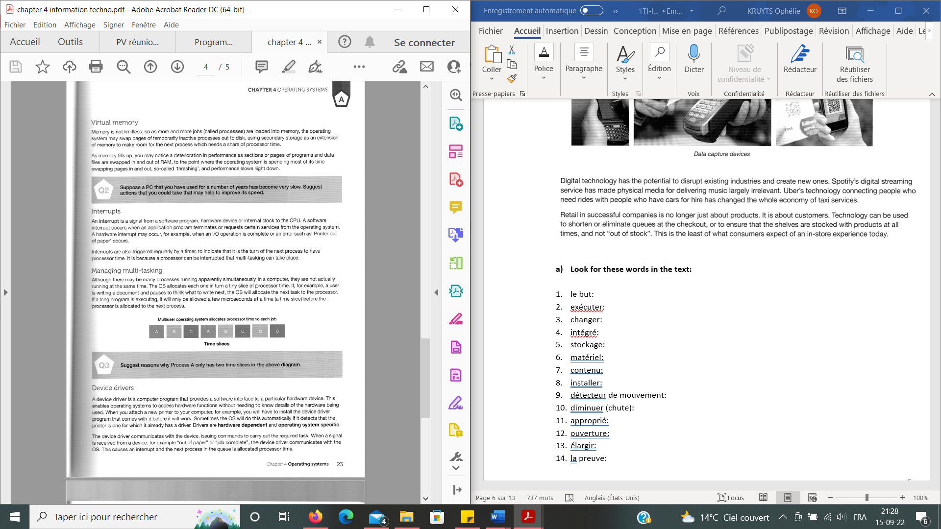

1. **What would you do in the following situation?**

🡪 Suppose a PC you have used for a number of years has become very slow. Suggest (at least) two actions that you could take that may help to improve its speed.

* Clean the storage (delete software you don’t use anymore.)
* Add RAM
* Do not open too many apps at the same time.



1. **Answer the question:** suggest reasons why Process A only has two time slices in the diagram.

* **Maybe the process asked for somethimes that takes a lot of time …**



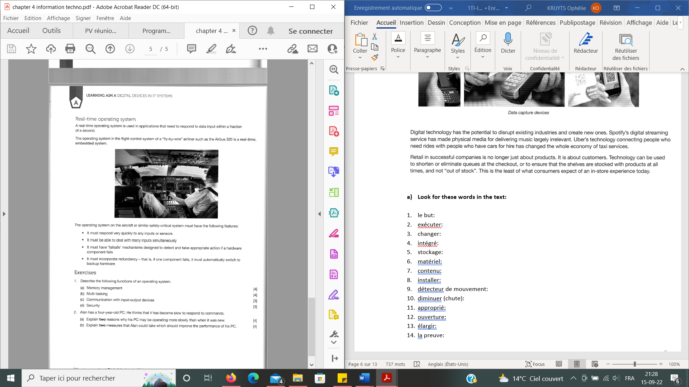

1. **True or false? Correct the sentence if it is false or give details if it is true.**

**“***The operating system has to deal with inputs very quickly.*”

True 🡪 It has to be as fast as possible

1. **Vocabulary exercises.**
2. **Find the translation of the following words in the text.**

* Gérer, diriger : (p.4) to manage
* Changer, échanger : (p.5) to switch
* En fait, vraiment : (p.7) actually
* Déclencher : (p.7) to trigger (> a trigger = la gachette)
* Bien que, quoique ; mais : (p.7) Although

1. **Match the words with the definitions.**

|  |
| --- |
| *a mainframe - standalone - to run something - to carry out - a clipboard - a directory - to be embedded in something* |

|  |  |
| --- | --- |
| to do and complete a task | To carry out (=effectuer) |
| a large, powerful computer, usually the centre of a network and shared by many users | A mainframe |
| to operate or function; to make something do this | To run something |
| to be fixed in a substance or solid object | To be embedded in sth |
| able to be operated on its own without being connected to a larger system | Standalone (=indépendant) |
| a file containing a group of other files or programs in a computer | A directory |
| a place in a computer’s memory where information from a computer file is stored for a time until it is added to another file | A clipboard |

1. **Put the words in the correct sentences. Write the correct tense/form.**

|  |
| --- |
| *to fill up – to enable – biometric – slice of – limitless – to deal with – to issue – whilst* |

1. This new programme (british)/ program (usa) will enable (=autoriser/active) older people to study at college.
2. Another since of (= part/morceau) cake, anyone?
3. In the UK it is illegal to drive whilst (=en même temps, pendant que = plus formel que while) holding a mobile phone.
4. The ditches (*fossés*) were filed up with mud.
5. She is used to (+ *-ing*) dealing with (=gérer, s’occuper de –sens négatif ->< version positive = to manage) all kinds of people in her job.
6. A warning was issued (=diffuser) yesterday by the government, asking people to stay in their homes.
7. The possibilities were almost limitless (=sans limite)
8. The major biometric methods include face, voice, fingerprint and iris recognition.
9. **Describe (in English) the following functions of an operating system:**
   * Memory management:

(L’OS gère la mémoire lui-même via plusieurs niveaux/couches)

The OS manages memory itself via several levels/layers.

* + Multi-tasking:

L’OS doit être capable d’effectuer plusieurs taches en même temps).

The OS (must) / has to be able to perform several tasks at the same time

* + Communication with input-output devices:

(L’OS doit être capable de communiquer correctement avec les entrées/sorties de l’utilisateur)

The OS has to be able to communicate rightly / effectively with the user’s input-output devices.

* + Security:

(L’OS doit être capable de g”rer les menaces extérieures)

The OS has to be able to deal with external threats.

1. Alan has a four-year-old PC. He thinks that it has become slow to respond to commands. Explain two reasons why his PC may be operating more slowly than when it was new.

* Because of an old CPU.
* Because it could have too many software / apps stored (= need to clean it up)

1. **GRAMMAR (*ALTISSIA*)**

* **Past continuous**

<https://learn.altissia.org/platform/#/discover/GRAMMAR/PAST/lesson/EN_GB_A2_GRAMMAR_PAST_CONTINUOUS>

1. Source: <https://www.youtube.com/watch?v=Y_9t3eQFmU4&ab_channel=GCFLearnFree.org>
2. Source (adapted from): <https://www.freecodecamp.org/news/why-are-there-so-many-programming-languages/>
3. Source : <https://www.youtube.com/watch?v=Z-BO6IYTgJg&ab_channel=Codecademy>
4. Source: <https://www.youtube.com/watch?v=mhpslN-OD_o&ab_channel=marselluh>